**Azure POC 3 (Azure Data Factory)**

Scenario – We have some data available in blob storage as csv format. We need to copy that data into Azure SQL database.

Storage account

1. Create a blob storage.

1. Create an Azure SQL database and create a schema for the above data.(*change the Phone column as Varchar(10))

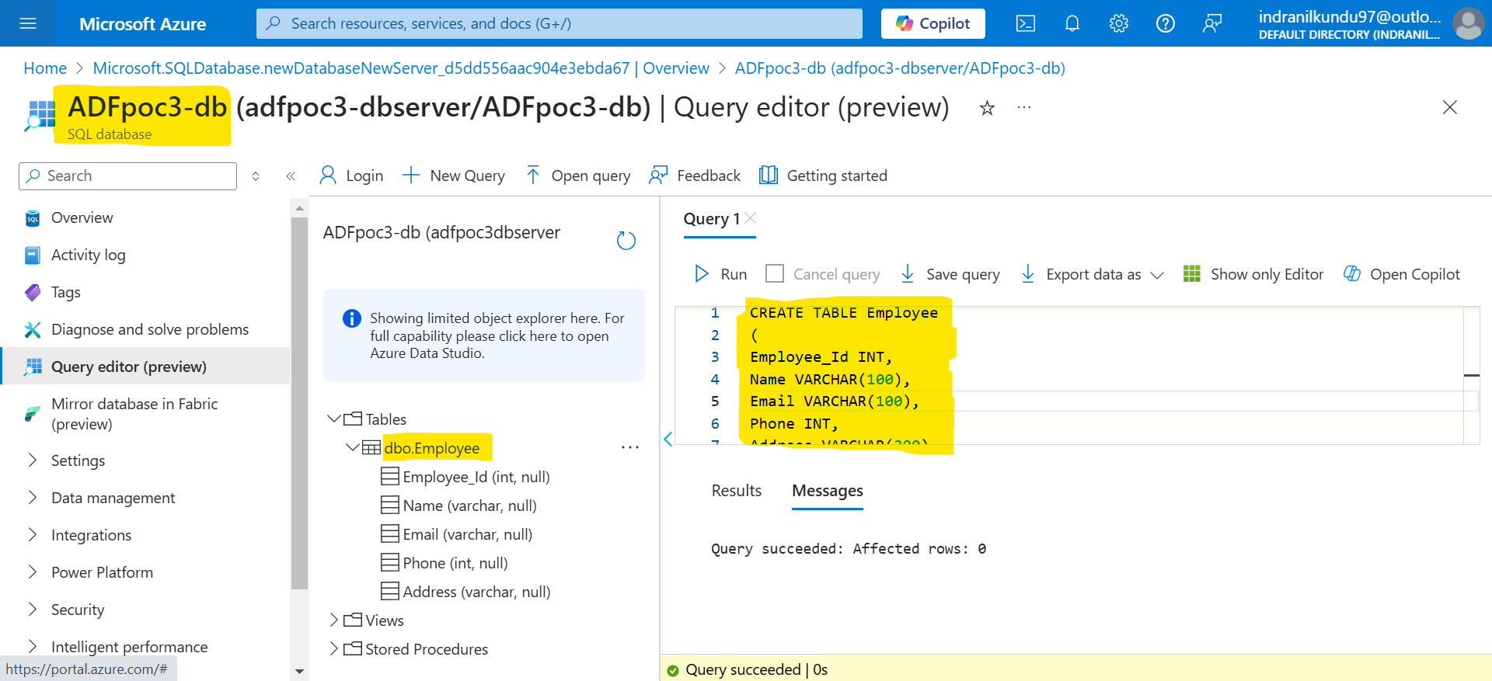

1. Create an Azure Data Factory pipeline and take Copy data activities.

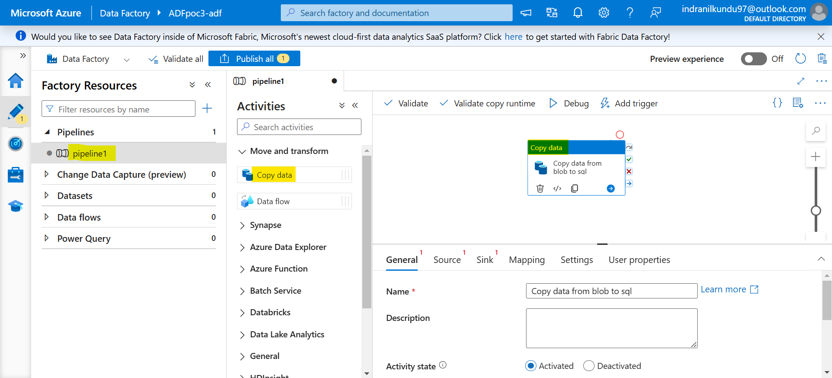

Set your Source where your data is present.

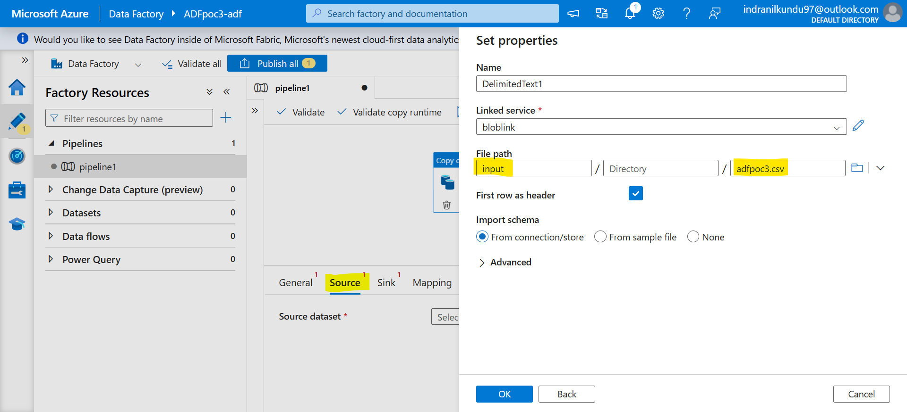

Set your Sink to SQL Database as destination.

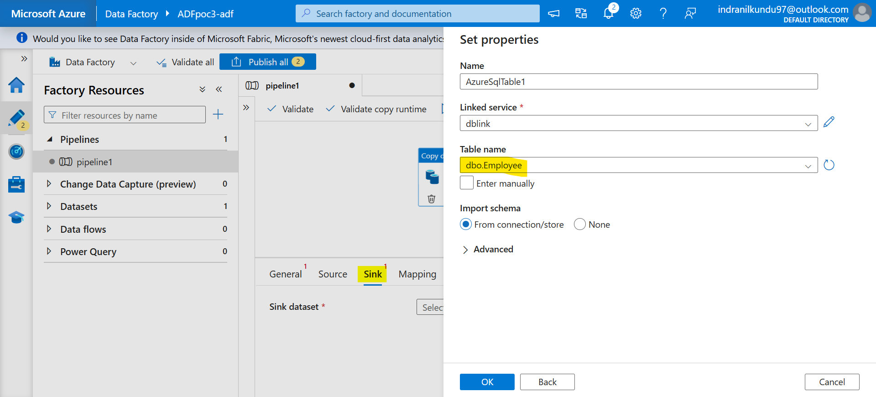

Click on Mapping to check & validate column matching between Source and Sink. -> then Validate all -> Publish all -> trigger now to run the pipeline.

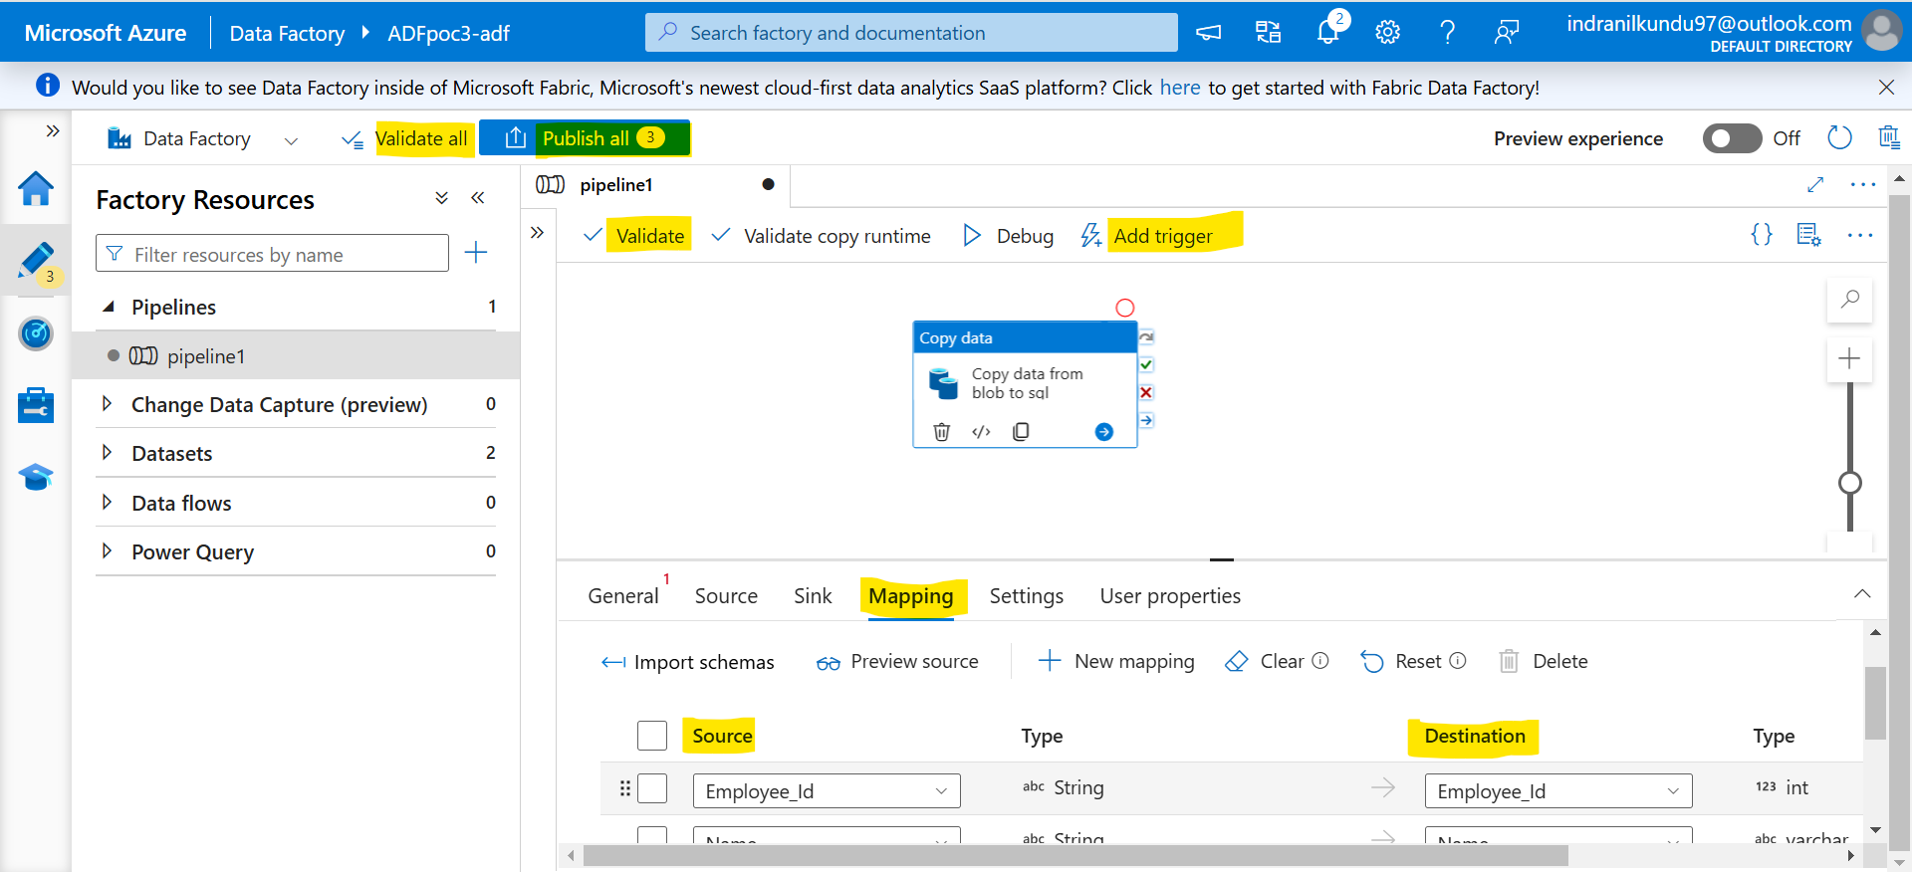

Monitor the Pipeline run.

Check the Database that all those data is populated or not.

